Taxes
Oct 1, 2015 @ 11:22 Am 4,117 Views
Tesla Prices To Triple In Denmark As Tax Incentives Are Rolled Back: Will Other Countries Follow?

Kelly Phillips Erb
FORBES STAFF

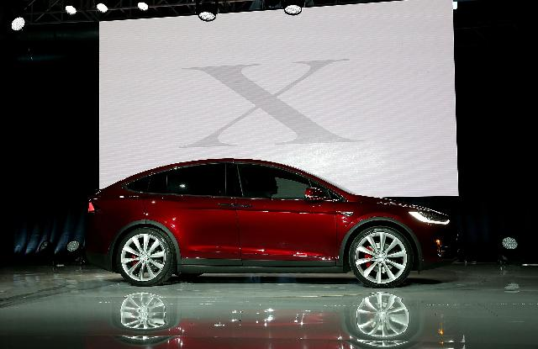
FREMONT, CA – SEPTEMBER 29: A new Tesla Model X Crossover SUV is displayed on September 29, 2015 in Fremont, California. After several production delays, Tesla CEO Elon Musk officially launched the much anticipated Tesla Model X Crossover SUV. (Photo by Justin Sullivan/Getty Images)
Tesla Motors TSLA -3.55% launched its Model X SUV this week and eager buyers were already in line to snatch up the first new offering from the car dealer in two years. You had to be prepared to wait, however: the highly anticipated SUV had a waiting list of 20,000 prospective buyers when it launched. The success of this next chapter for Tesla seems to indicate that the electric car is here to stay.
Not every country is embracing more fuel efficient cars, however. Denmark has announced that it intends to eliminate all tax breaks for electric cars – that includes, of course, the venerable Tesla lines. The move will be somewhat gradual: the tax will be phased back in beginning in 2016 with the full repeal of the exemption in 2020.
The popular Tesla Model S, which debuted in 2012, has topped best seller lists across the globe. According to Tesla’s Danish website, available incentives for the Model S include exemptions from green taxes and exemptions from the vehicle registration tax of 180%. The site notes that the latter exemption is only good through December 2015. The move by Denmark’s government to eliminate the exemption will definitely change the pricing on the car: without the exemption, the price of the Model S would increase from about 650,000 kroner ($97,233 US) to around 1.8 million kroner ($269,262 US). (Note: Denmark uses the krone as its currency. It does not use the euro and is not currently part of the Eurozone.)
In the United States, the Model S starts at around $71,100. The price of the car can be offset with a fuel tax credit worth up to $7,500 (at a 28% tax bracket, assuming taxable income of $100,000 in 2014, that’s the equivalent of a $26,786 tax deduction). The federal tax credit is available in all states; depending on the state where you live, additional tax credits and incentives may also apply in an effort to encourage the purchase of more fuel efficient behaviors.
Engineering tax policy to drive social behavior is nothing new. We do it all of the time in the US via excise taxes on cigarettes and alcohol as well as tax breaks for financing homes and giving to charity. And clearly, the intention when it comes to providing tax breaks for electric and hybrid cars is to encourage the purchase of those fuel efficient vehicles. But, some argue, that creates artificial incentives for some manufacturing companies and, perhaps, a potential for dishonest behavior for others (as with Volkswagen). tax distortion
So why the change in Denmark? Does it actually mark a change in social behavior or is it something more? It’s likely the latter. Like much of Europe, Denmark’s economy has been experiencing a slowdown in recent years. The new government is scrambling for ways to save money and boost revenues. According to the Danish Tax Ministry, allowing the tax exemption for electric cars to continue next year would cost the country some 650 million kroner ($97.52 million US).
According to Elon Musk, Tesla’s founder, the move sends the wrong signal to consumers. Musk said, about the repeal, “This is an important crossroads in history. When the tax exemption expires on January 1, it will really damage the potential for electric cars.”
Denmark isn’t the only country considering a phaseout. In Norway, one in five new cars sold in June was electric. But the loss to the tax coffers due to tax breaks for electric cars drivers may not be sustainable. The government has indicated that phaseouts are likely beginning in 2018.
Similarly, a £5,000 ($7576.50 US) tax break on new cars in the United Kingdom will expire once 50,000 have been sold. According to the BBC, that target could now be reached before the end of the year. Other incentives, including a reduce company car tax, will remain in place – at least for now.
Not all countries are turning away from offering breaks to consumers. After Musk targeted Germany as Tesla’s next big target, Germany’s Minister for Economics indicated that the country needed to ramp up incentives for electric vehicles. That theme was echoed earlier this year when German Chancellor Angela Merkel said her government was considering providing additional incentives for electric cars and would have a decision by the end of 2015.
Source: http://www.forbes.com/sites/kellyphillipserb/2015/10/01/tesla-prices-to-triple-in-denmark-as-tax-incentives-are-rolled-back-will-other-countries-follow/2/
Task:
Using standard formatting for academic papers answer the following research questions:
1, How will the elimination of tax breaks of electric vehicles affect the market outcome in the market for electric vehicles and related stakeholders (consumers, suppliers, government)?
2, How will the effect of the tax depend on the own-price elasticity of demand for electric vehicles?
3, how will the elimination of tax breaks of electric vehicles affect the market outcome of petrol cars (consumers, suppliers, government)?
4, do you think it is a good move to roll back the tax incentives for electric vehicles? You may analyse from various perspectives, such as consumers, suppliers of electric vehicles and petrol cars, and government.

- introduction (about 60 to 100 words) The objectives of the essay must be clearly stated.
- Elimination of tax breaks of electric vehicles affecting the market outcome
- Tax dependent on the price elasticity of demand for electric vehicles
- Elimination of tax breaks of electric vehicles affecting the market outcome of petrol car
- Perspectives on tax incentives for electric vehicles
- Conclusion (100)
- References (at least 5 start on anew paragraph)

